Movie Landing Page Website Design

Name: PALADUGU SAKETH CHOWDARI

Mail Id : chowdarysaketh96@gmail.com

Phn No : 8125429052

Roll N0 : 20HU1A0578

College Name : Chebrolu engineering college

**Source Code:**

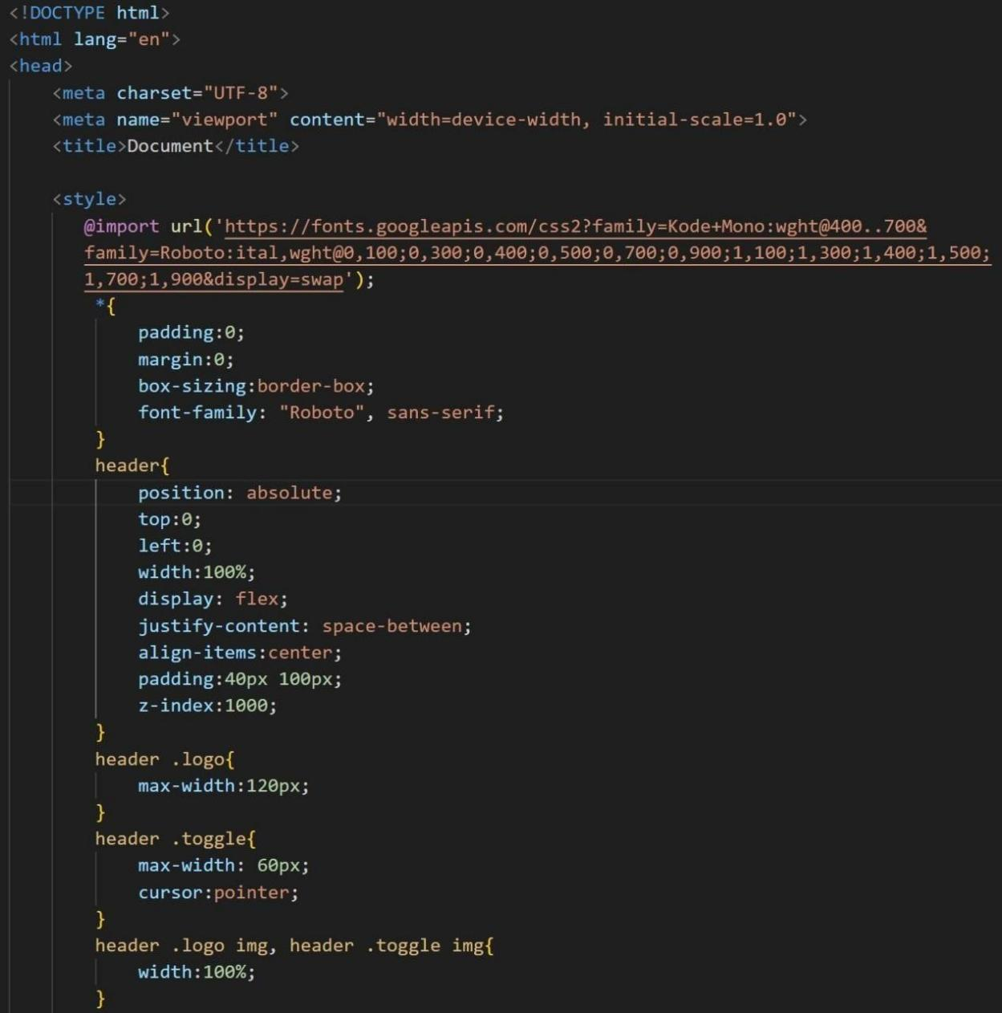

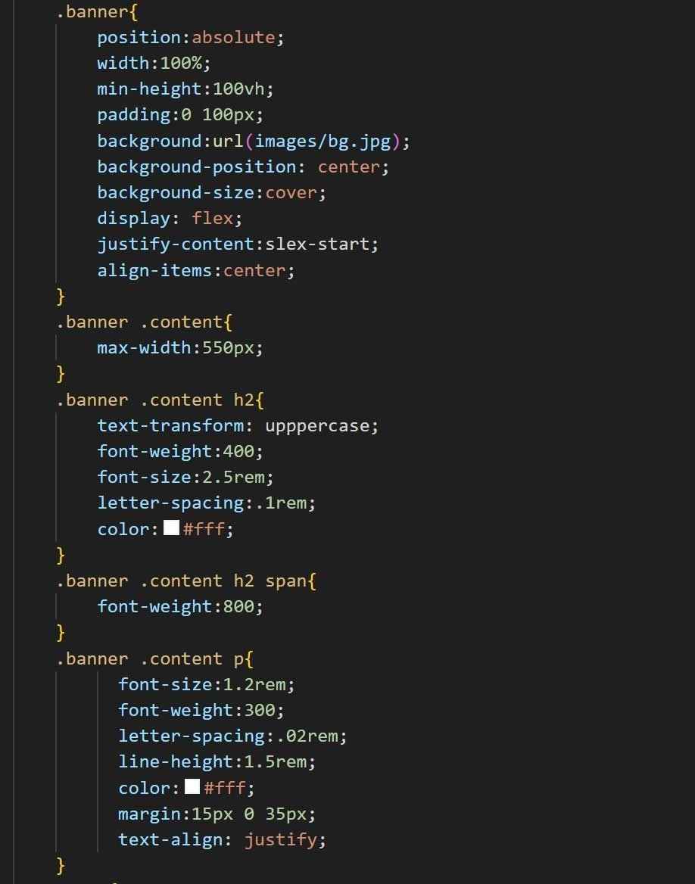

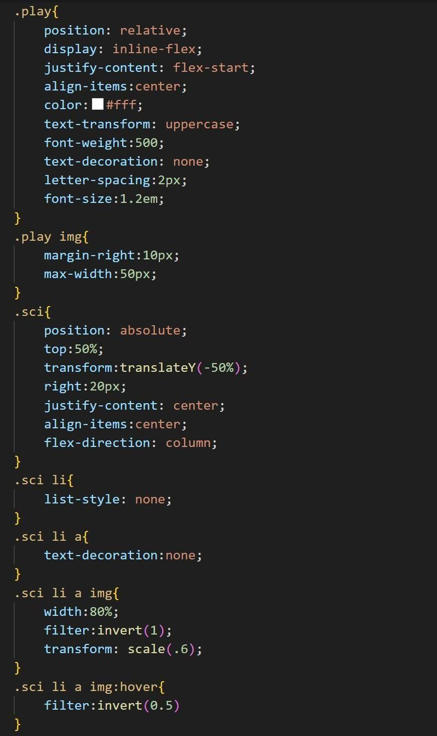

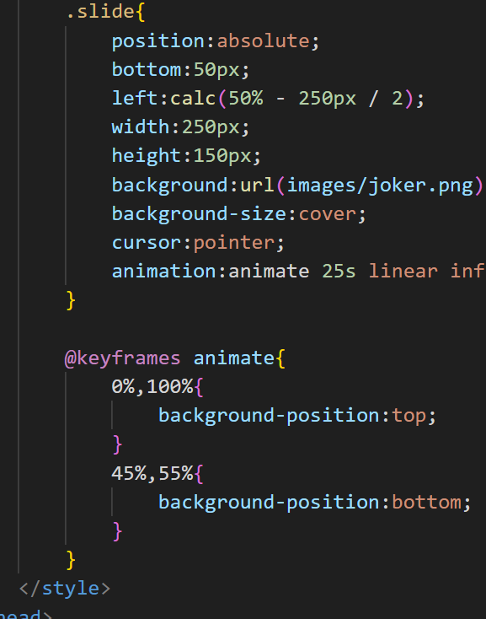

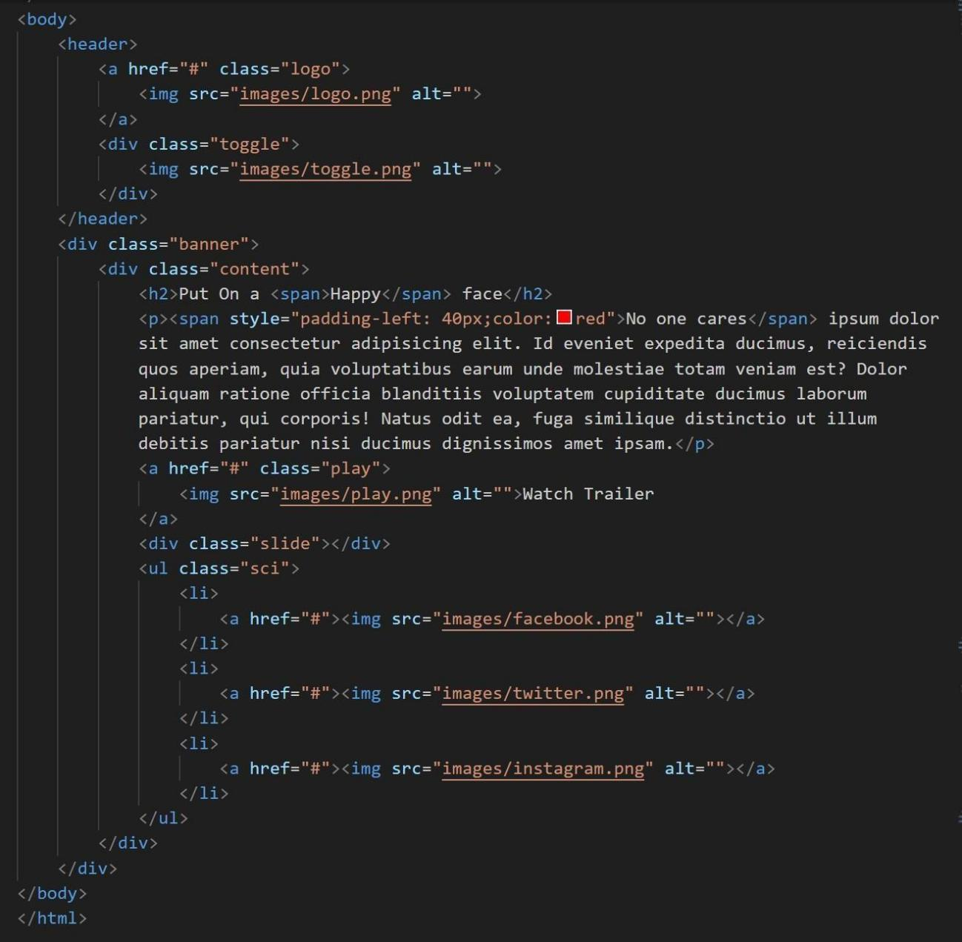



**Output :**